**Q.1**

**What is the difference between UI and UX? Explain in your own words.**

**Answer:**

User Interface (UI) and User Experience (UX) are integral components of design in the digital realm. UI deals with the visual and interactive elements, emphasizing aesthetics and usability, serving as the bridge between users and the system. On the other hand, UX encompasses the broader user journey, aiming to create a seamless, enjoyable, and efficient experience by understanding user needs and optimizing functionality.

Effective UI design ensures that the product looks appealing and is easy to navigate, while UX design ensures that it satisfies user needs, fosters positive emotions, and solves problems effectively. Together, UI and UX work in tandem to create user-centered digital products that not only look great but also provide a satisfying and meaningful experience, ultimately leading to user satisfaction and product success.

**Q.2**

**Who is a frontend developer? Explain the roles and responsibilities in your own words.**

**Answer:**

A frontend developer is a key player in web development, responsible for crafting the visual and interactive aspects of websites and web applications. Their role involves designing user interfaces, optimizing performance, ensuring cross-browser compatibility, and collaborating with various team members. They must excel in coding with HTML, CSS, and JavaScript while adhering to best practices and accessibility standards. Frontend developers are crucial for delivering a seamless and engaging user experience, and they play a vital role in bridging the gap between design and functionality. Continuous learning and effective communication are essential for success in this dynamic field, as technology and user expectations evolve rapidly.

**Q.3**

**Who is a backend developer? Explain the roles and responsibilities in your own words.**

**Answer:**

A backend developer is a vital part of a software development team, responsible for building the hidden infrastructure that powers web applications and software systems. Their roles encompass server-side logic, database management, API development, security implementation, and optimizing performance. Collaboration with front-end developers and effective documentation is crucial for a cohesive development process. Backend developers must also stay updated with evolving technologies to maintain and enhance application functionality. Ultimately, they play a pivotal role in

ensuring the reliability, security, and scalability of applications, contributing to a seamless user experience.

**Q.4**

Create your own GitHub & LinkedIn accounts. Share the screenshot of both of your accounts and share your profile links of GitHub & LinkedIn in the solution

**Answer:**

**GitHub Profile:**

**Profile Link:**

https://github.com/ArslanHaider56

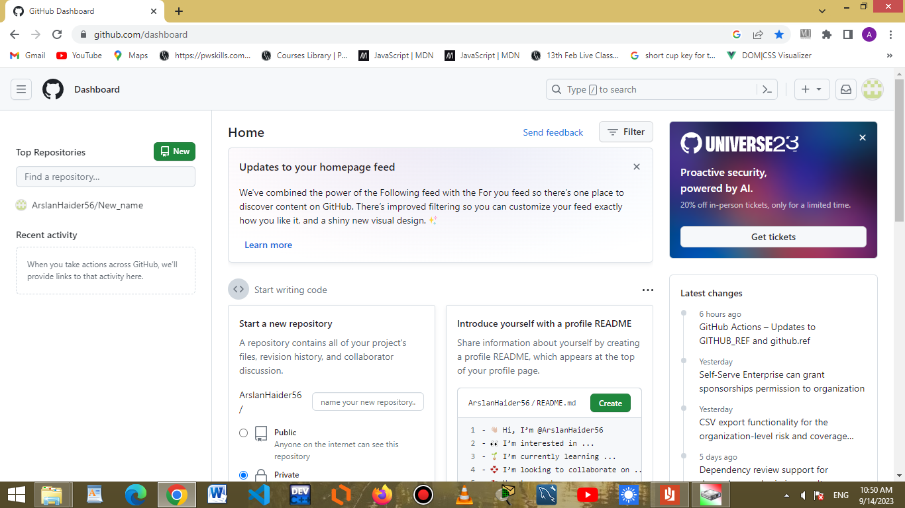  
  
**LinkedIN Profile:**

**Profile Link:**

https://www.linkedin.com/in/arslan-haider-485175291



**Q.5**

**Write your first blog on your favorite platform and share the link to the blog. ( you can choose any topic for writing your 1st blog).**

**Answer:**It is my **Hashnode Profile** where I have written a Blog.

**https://hashnode.com/@arslan94**